Python Series Test

# Submitted by : Akhila M V

# S1 MCA

# ROLL NO: 104

Question 1:

* **Ques1.py**

import csv

dict_value = [

{'Name': 'AKHILA', 'MFC': 45,'DC':35,'DS':40,'ASE':30},

{'Name': 'ARCHITHA', 'MFC': 40,'DC':'25','DS':'30','ASE':'30'},

{'Name': 'AKSHITHA', 'MFC': 50,'DC':15,'DS':45,'ASE':38},

{'Name': 'ARCHANA', 'MFC': 25,'DC':23,'DS':30,'ASE':31},

{'Name': 'APARNA', 'MFC': 46,'DC':42,'DS':34,'ASE':28},

{'Name': 'ARATHY', 'MFC': 40,'DC':32,'DS':29,'ASE':27},

{'Name': 'SREELAKSHMI', 'MFC': 48,'DC':37,'DS':42,'ASE':39},

{'Name': 'KANAGA', 'MFC': 42,'DC':45,'DS':41,'ASE':37},

{'Name': 'DHANYA', 'MFC': 48,'DC':44,'DS':25,'ASE':24},

{'Name': 'BHAVYA', 'MFC': 50,'DC':35,'DS':47,'ASE':39}]

print("\n\nStudent Names and marks:\n")

fields = ["Name","MFC","DC","DS","ASE"]

with open('stud.csv','w') as c:

writer = csv.DictWriter(c,fieldnames=fields)

writer.writeheader()

writer.writerows(dict_value)

c.close()

mfc=0

dc=0

ase=0

ds=0

n=0

with open('dict.csv', 'r') as csvread:

reader= csv.DictReader(csvread)

for data in reader:

if n==0:

print(f'{" ".join(data)}')

n=n+1

print(f'{data["Name"]}{data["MFC"]} {data["DC"]} {data["DS"]} {data["ASE"]}' )

with open('stud.csv','r') as csvread:

reader = csv.DictReader(csvread)

print("\n\nStudent Names and Percentage:\n")

for row in reader:

print(row['Name'],":",(int(int(row['MFC'])+int(row['DC'])+int(row['DS'])+int(row['ASE']))/200)*100)

mfc=mfc+int(row['MFC'])

dc=dc+int(row['DC'])

ase=ase+int(row['ASE'])

ds=ds+int(row['DS'])

print("\nAverage of subjects\n")

print("MFC",mfc/10)

print("DC",dc/10)

print("DS",ds/10)

print("ASE",ase/10)

**OUTPUT:**

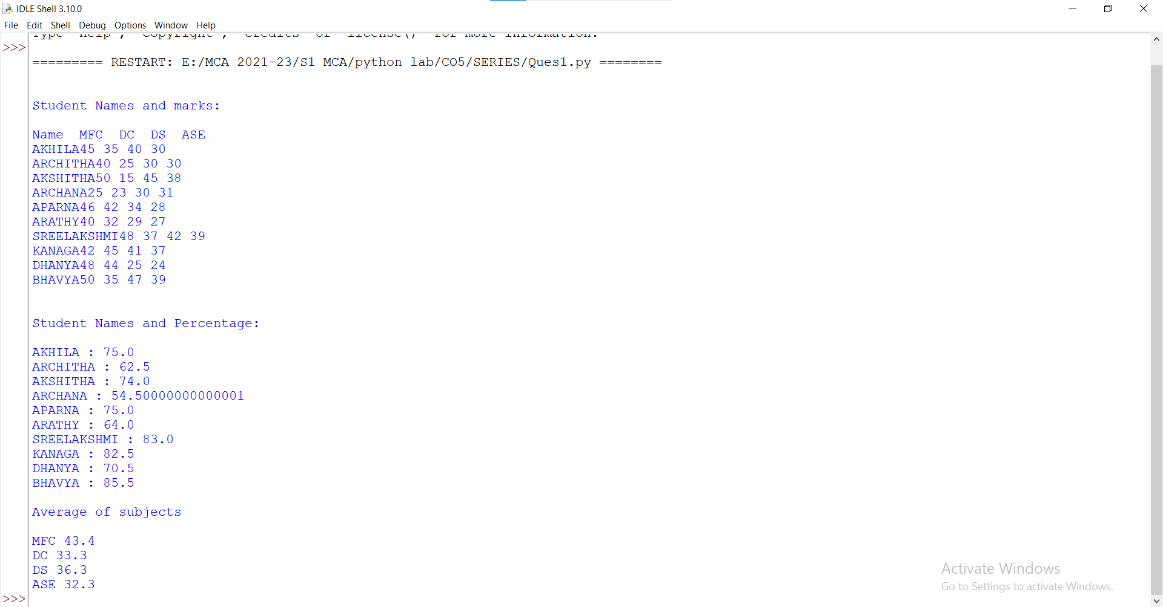

Question 2:

* **Ques2.py**

file_obj = open('file1.txt','r+')

condition = True

print("the line which have more than 5 letters and starting with capital letter is:")

while condition:

line = file_obj.readline()

words = line.split(" ")

if(len(words)>5):

x = words[0]

if(x[0].isupper()):

print(line)

if not line:

condition = False

print("end of the file")

* **file1.txt**

Apple is red.

Strawberries are one of the most popular berries in world.

An orange is orange in color.

Carrot is orange.

grapes are small.

**OUTPUT:**

